**What is the difference between a LAN and a WAN?**

LAN is a local area network which includes computers connected in a small area like a building.

A WAN, wide area network, on the other hand, connects computers across a larger area like corporate branches.

**What are the advantages of wireless networks compared with wired networks?**

Wireless networks do not need wires like wired networks, which reduces the cost and increases the portability of devices.

**What are the three major protocols used in sending and receiving email?**

IMAP, SMTP, and POP3.

**What is a protocol stack?**

A suite/set of protocols part of a larger idea on how to define data transfer in networks.

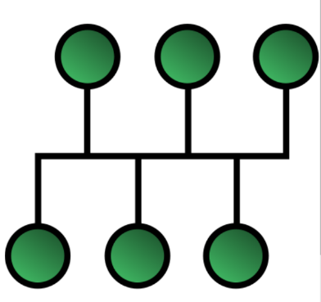**Draw a ring, bus, and star topology.**

**---**

**Challenge Questions:**

**Why might a supermarket chain use a WAN to connect all its stores?**

WANs are used to connect computers that are connected far apart from each other. As the stores are separated, they should a WAN to connect them.

**Explain the advantages of P2P networks regarding privacy when sharing files.**

In P2P networks, devices are connected directly without another computer in between and this makes sure that the files are only accessible by the sender and receiver. In a client-server style network, the shared files may be stored and accessed by the owners of the server.

**Most networks in use in schools and offices today are based on the star topology. Why do you think this topology is used?**